Q-4-2
Correct answers marked with an asterisk (*)

1) A 95% confidence interval for a population proportion is (0.67, 0.83).
What is the sample proportion?
a. 0.67
b. 0.83
*c. 0.75
d. 0.08

2) A 95% confidence interval for a population proportion is (0.67, 0.83).
What is the margin of error?
a. 0.67
b. 0.83
c. 0.75
*d. 0.08

3) A 99% confidence interval for a population proportion is 0.20 ± 0.09. What is the confidence interval?
a. (0.155,0.245)
b. (0.21,0.22)
*c. (0.11,0.29)
d. The confidence interval cannot be determined.

4) The spinning dancer (or silhouette illusion) is a moving image of a woman that appears to be spinning. Some people see her spinning clockwise and some see her spinning counterclockwise. A student showed other students this and found that 30 out of 50 (or 60%) saw her spinning clockwise. The student researcher was interested in the probability of a randomly chosen student that would see the dancer spinning clockwise. The student created the following null distribution.
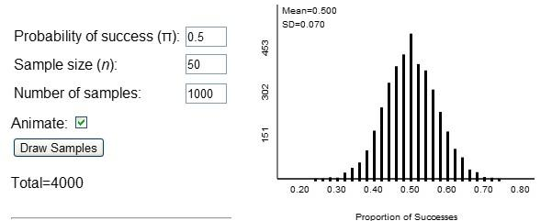
Using the information provided above, determine a 2SD confidence interval for the long-run probability a randomly chosen student would see the woman spinning clockwise. (Don't use any other applet to do this, just the applet output and information above.)
a. (0.36, 0.64)
*b. (0.46, 0.74)
c. (0.53, 0.67)
d. (0.43, 0.57)

5) Many studies have investigated the question of whether people tend to think of an odd number when asked to think of a single-digit number (0 through 9; 0 is considered an even number). When asked to pick a number between 0 and 9, out of 70 students, 42 chose an odd number. Let the parameter of interest, $π$ , represent the probability that a student will choose an odd number.
Are conditions met to use theory-based methods for conducting a 95% confidence interval?
a. Yes, because there were two possible outcomes.
b. Yes, since the number of students is larger than 30.
*c. Yes, since the number of students who chose an odd number, and the number of students who chose an even number, are both greater than 10.
d. No, since the sample size is too small.

6) Hill and Barton (Nature, 2005) conducted a study to investigate whether Olympic athletes in certain uniform colors have an advantage over their competitors. They noted that competitors in the combat sports of boxing, tae kwon do, Greco-Roman wrestling, and freestyle wrestling are randomly assigned to wear red or blue uniforms. For each match in the 2004 Olympics, the uniform color of the winner was recorded. Hill and Barton found that in the 457 matches, the competitor wearing red won 248 times (54.3%), whereas the person wearing blue won 209 times (45.7%).
Based on these data, use the 2SD method to construct a 95% confidence interval for the proportion of matches won by competitors wearing red uniforms.
*a. (0.497, 0.589)
b. (0.454, 0.546)
c. (0.493, 0.593)
d. (0.483, 0.602)

7) Suppose a 95% confidence interval for a population proportion is (0.21, 0.43). How would the width of the confidence interval change if the confidence level was changed?
a. Both a 99% confidence interval and a 90% confidence interval would both be wider.
*b. A 99% confidence interval would be wider and a 90% confidence interval would be narrower.
c. A 99% confidence interval would be narrower and a 90% confidence interval would be wider.
d. Both a 99% confidence interval and a 90% confidence interval would be narrower.

